I NS T R U C T I 0 N M A NU A L
_________________________________________________________________________

GRAPHIC VIEW Camera

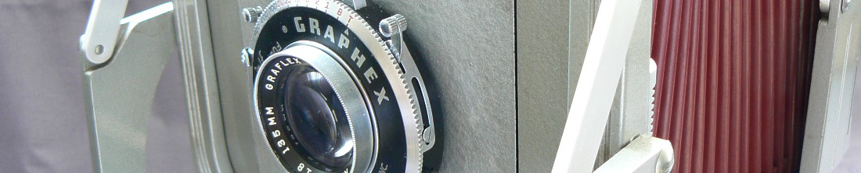

The GAPHIC View camera is an accurately-made photographic instrument: treat it as such and it will return to you long years of useful service. An instrument should never be forced. Follow these instructions the first time you- inspect this camera. See how little force is required to loosen, tighten and move, the various controls, and never exceed this force.

The camera and its tilting base are separate in the caning case supplied With the camera. Be sure to notice how they fit in the cast
before removing them. The first step in setting up the camera is to attach the combination base and revolving the mount to a steady tripod The revolving and tilting movements of this base are controlled by the long handle, which locks them with a clockwise-movement. Then open the bed-clamp, up the camera by one end of the bed as you would a club, and lift it out of the case. Separate the front and back of the camera on the bed and lay the bed on the base, close the bed-clamp, and screw it down firmly.

Focusing movements of the front end and of the camera along
the bed are controlled by the two large black focusing knobs, which are
locked, by turning the light finish locking wheels anti clockwise direction.
When these wheels are turned counter-clockwise against the focusing knobs,the front and back should move freely. Always lock both of these wheels before making an exposure.

When working extremely close-up, focusing by movement of the lens is often undesirable because it changes the scale of reproduction. In such cases focus by moving only the rear of the camera. The effect of moving the whole camera can be secured by adjusting both front and rear along the bed making it possible to change the scale without moving the tripod.

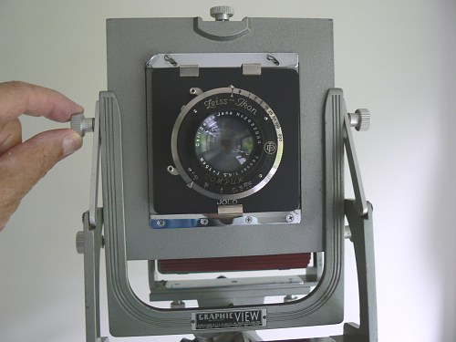
1
Rising Front To raise the front, unlock the rack-and-pinion by moving either control-knob to the left (as seen from the rear of the camera). Raise the front by turning the knob, and lock the front by moving the knob to the right. (Figure 1)

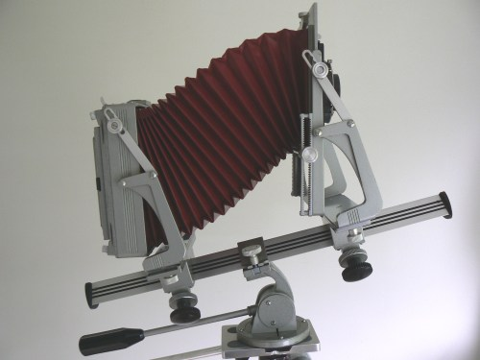
2
Rising and falling front movements are also obtained by pointing the bed up or down, and tilting the front and back into parallel with the subject. (Figure 2)
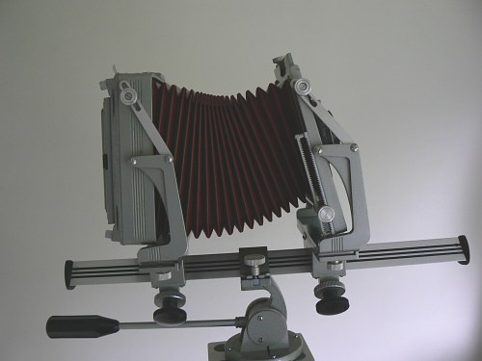
3
To tilt the front and back, slightly loosen the knobs on the braces. The slots in these braces are of such length that tilting the front and back to the full in the same direction will make them parallel. The notches in the centre of the slots indicate the vertical setting, and the intermediate notches give the front and back an intermediate tilt backward. (Figure 3) Be sure to tighten the brace knobs before final focusing.

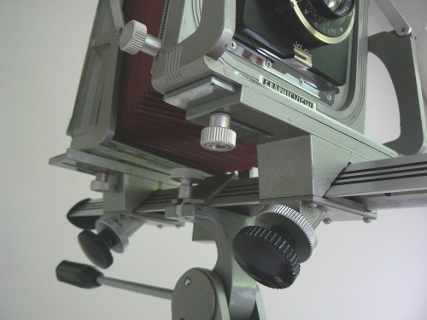
4
Lateral shift is accomplished by loosening the lock-, knobs under the front or back and pressing against the side of the front or back carriage-base (No. 25633) and the yoke (No. 25637). A spring-click indicates dead centre. (Figure 4.)
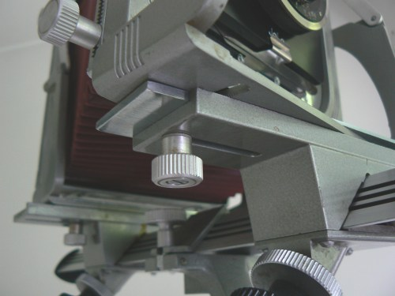
5
To swing the front or back loosen the two knobs just referred to, and push on one side of the front or back yoke. A spring-click indicates dead-centre. (Figure 5.) Be sure to tighten these knobs before final focusing.
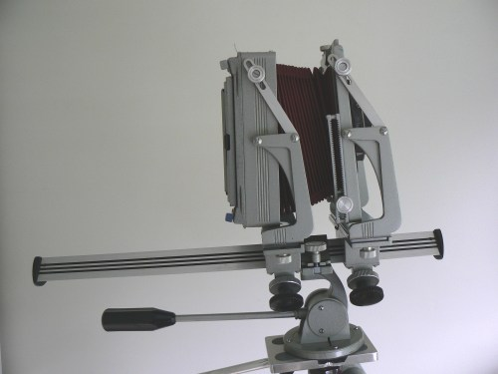
6
For wide-angle lenses. Both the front and rear carriages may be moved forward of the bed clamp to prevent the bed from jutting into the field of view (Figure 6). When the subject is not closely accessible the clamp may be moved to the extreme rear of the bed so the camera overhangs the obstruction. Be sure that the tripod is balanced or braced when this is done.

The spirit-level on the top of the back helps to bring the back into the vertical position.

The back, of close precision fit, is reversible for vertical or horizontal compositions. To remove the back, merely unhook the two upper spring-clips from the back-pins and move the top of the back approximately 2" to the rear while allowing its bottom edge to rest on the two lower spring-clip. Then rotate the back, to the right or left by lifting one of the lower corners off the bottom spring-clip.
To replace the back reverse the above order, making sure that the long vertical light-lock ribs on the back are engaging properly in their corresponding grooves in the back-frame before you actually snap the back closed. Clips in the two upper springs will hold a focusing cloth on the camera.

The metal lens board, 4" square, is held in place by a slide-lock. Insert lens boards with the bevelled edge under the retaining strip at the bottom.

The lens-shade screw on top of the front standard is to fasten the accessory accordion-type lens-shade.

Replacing in the Case Bring all swings, tilts and shifts back to neutral, and move both front and rear carriages to the centre of the bed. Place the camera upside down in the centre compartment with the focusing knobs toward the cover hinge and the locking wheels turned counter-clockwise (unlocked).
Shut and fasten the bed-clamp, and tilt and lock the base as for a 9O_degrees downward shot. Place the base handle in the grooves with the base to the right so that the bed clamp and its knurled knob straddle the low partition in the right compartment. If the end of the camera bed interferes with the base, move the bed by turning the focusing knobs with the camera in the case.
To prevent confusion in correspondence, use the parts numbers given on page 4 of this manual,
The Graflex Technical Department is at your service for all photographic problems.
The Graflex Repair Department is prepared to clean and adjust all Graflex-made equipment.

This page was brought to you by Jo Lommen Classic Cameras.
Phographs © Jo Lommen

Manual text copied from Graflex original manual.

